
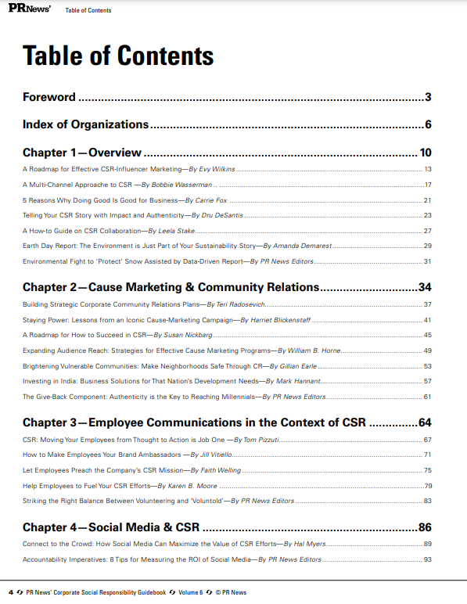
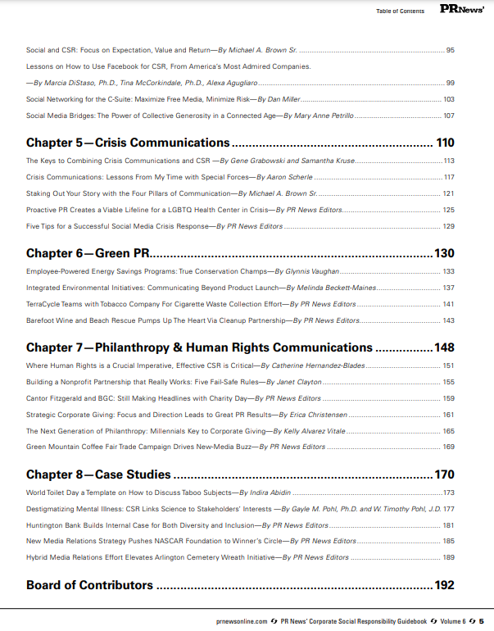
SOCIAL MEDIA AND CSR
Social Media and Corporate Social Responsibility: Focus on expectation, value, and return
By Michael A. Brown Sr., Ph.D.

Social networking is a perfect way for organizations to connect with the environment and impact social welfare, assessing the impact of corporate actions and activities on the community and its citizens. Social media platforms are the cutting-edge tools that allow organizations to have an effect in real time, while using the hottest interactive approach we know today.
I suggest a focus on the social media value proposition to help achieve the corporate citizenship that is so important in today’s public interactions. Organizations should look beyond near-term financial benefits and leverage short-term costs (either time or expenses) that promote positive social and environmental change.
Social capital theory offers a basis for my approach, suggesting that the efficiency of society can be improved by facilitating coordinated actions. For organizations, social networking is a two-step, voluntary process where one accepts or rejects participation. I believe organizations can develop a framework that identifies participation determinants and opportunities. To be effective in social networking efforts, organizations must create networks that feature fluid communications and benefits that are easily understood. That’s why social networking is beneficial to companies that are dedicated to understanding the challenge of achieving desired behaviors (Putnam 1993).
I recommend that companies take advantage of all that social media has to offer by leveraging the expectation, value and return on investment (EVR) that I see in every social media interaction. EVR is about identifying, achieving, and nurturing social capital, which is the value or reward for effectively applying the social media strategy. EVR is a social media focus that presents planning practices that address goals, establish roles, and seek feedback and verification that the social media approach is working. EVR has several objectives. First, identify and improve social media participation by delivering on expectations of shared value and a worthy return on each company’s, or participant’s, investment of time and attention. Second, develop or improve organizational or personal brand using a two-way communication arrangement where valuable information is exchanged freely, and where giving and getting recognition matters to the participants. Third, develop a social media plan that addresses the goals required by the company or personal brand.
Effectiveness in social media relies on understanding the value proposition that affects acceptance of participation. Organizations quickly get involved in the digital conversation and then, at some later date, seek to understand return on investment. Focusing on expectation, value and return, and analyzing individual perceptions of effectiveness, are keys to social media success.
Social networking is an approach widely supported in organizations, helping them evaluate and take advantage of the psychological process of participating. However, organizations must do more by investigating their return on investment of time and attention. Problem is, this “return” is not often considered at the outset of social media activities. Because of the limited barriers to entry into social media activities, organizations are typically fully involved before return on investment becomes a consideration. That means organizations may be searching for a target they have never established.
By focusing on EVR early in the process, organizations can predict and promote the value proposition that affects acceptance or rejection of participation. At this point, the organization can target that participation to arrive at a designated end state. Those choices are made by companies, communities, and individuals every day, so a focus on EVR is a way to get involved in that process. The process is internal and people-focused, based on the self-perception of effectiveness. I call that phenomenon perceived improvement potential, or PIP. PIP predicts a person’s intention to behave in a certain way and determines whether they will actually exhibit that behavior. My initial research in this area is promising; however, I hope to establish PIP as part of a scored assessment that gives insight into the state of someone’s participation IQ.
But I digress. What I want to focus on is adjusting the social media process in a way that allows people to have a strategy for the valuable interactions that networking offers. The context of digital engagements relies on an understanding of social capital; that’s really what we’re building. Building social capital is one way to address collective problems quickly and solve them easily.
Those who build trust and social capital tend to be the catalysts for ensuring that companies and the communities in which they operate advance in pursuit of their stated goals. Social capital can also illustrate how active and trusting connections with others widen our awareness and reveal commonalities in society that often prove beneficial. Social media is shown to be the fastest way to arrive at these outcomes.
Social capital, which exists between people and corporations, is all about establishing relationships purposefully and employing them to generate intangible and tangible social, psychological, emotional, and economic benefits in short or long terms. Social capital can be examined in terms of five dimensions: networks or lateral associations between individuals and/or groups, reciprocity and expectation, trust and risk based on assumptions, social norms, and personal and collective efficacy.
There are many reasons why corporations bring people together online and use social networking to integrate virtual communities into existing business models. Companies are interested in social networking because of their potential to deliver measurable benefits like innovation, more effective marketing, more rapid access to information, lower costs and higher revenues.
In its Fall 2009 edition application and usage report, Palo Alto Networks (2009) reported that an Enterprise 2.0 survey showed that the top three business benefits identified were knowledge sharing at nearly 60%, reduced effort in information gathering (nearly 50%), and improved efficiency/speed of delivery (35%). Companies can address their communication, information, entertainment, or transaction purposes through integrating social media platforms across the business enterprise. Those corporations may find compelling benefits through the creation and implementation of a social media plan, which leads us to engagement.
Engagement is the conscious attempt to use interaction to gain attention and reputation. The process begins with an understanding of what you have to offer or, put another way, what knowledge can be shared that is worthy of giving and receiving input? The social media process has some distinct steps you’ll want to follow. They are creating compelling content, fostering adoption or participation, filtering incoming and outgoing information, and maintaining levels of activity. Along the way, it’s important to determine appropriate online spaces and channels, evaluating each social media space. When evaluating a social media space, evaluate and understand the audience of interest. Finally, set some goals and milestones to develop participation opportunities that will last.
Done well, companies will reap plenty of benefits in social media activities driven by engaging appropriately to gain adoption and trust within the community of interest. Adoption should be a by-product of good bookmarking and tagging practices, and of adding people to social media groups. Attention and reputation should reasonably offer continuing collaboration activities.
Company strategy must be based on sound engagement policies using social media solutions and community interactions. Synergy is an approach in networking efforts that integrates communications based on three central tasks. First, it’s important to identify the nature and extent of social relationships characterizing a particular community, its formal institutions, and the interaction between them. Second, organizations need strategies by which they can understand social relations, especially in terms of the extent to which social capital is being built and nurtured in a society or community. Third, companies need to identify ways to benefit from positive outcomes such as widespread cooperation, trust, or institutional efficiency. However, all the news isn’t necessarily good. Companies must also have a plan to mitigate risks from negative social media activities and unwanted results like sectarianism, isolationism, or corruption. Sound privacy policies and a social media plan are helpful in this endeavor.
I’m suggesting a valuable pursuit of social media through the process that is EVR. Focusing on value propositions, interactive behaviors between company, employee and community, and a strategy that tracks and measures progress can only lead to improved participation and results. EVR offers the chance to reap the benefits of a solid strategy that leads to success in conquering keys to social media participation: Expectation, Value and Return.

Goldsmith, S. and W. D. Eggers (2004). Governing by network: the new shape of the public sector. Washington, D.C., Brookings Institution Press.
PaloAltoNetworks (2009). The Application Usage and Risk Report: An Analysis of End User Application Trends in the Enterprise. Sunnyvale, Palo Alto Networks: 1-19.
Putnam, R. D. (1993). Bowling Alone. New York, Simon &amp; Schuster Paperbacks.
Safko, L. and D. K. Brake (2009). The social media bible: tactics, tools, and strategies for business success. Hoboken, N.J., John Wiley & Sons.

Bio
Dr. Brown is deputy director of Public Affairs, Joint Task Force Civil Support (JTFCS), Ft. Eustis, Va. He is also an Air Force retiree.

