
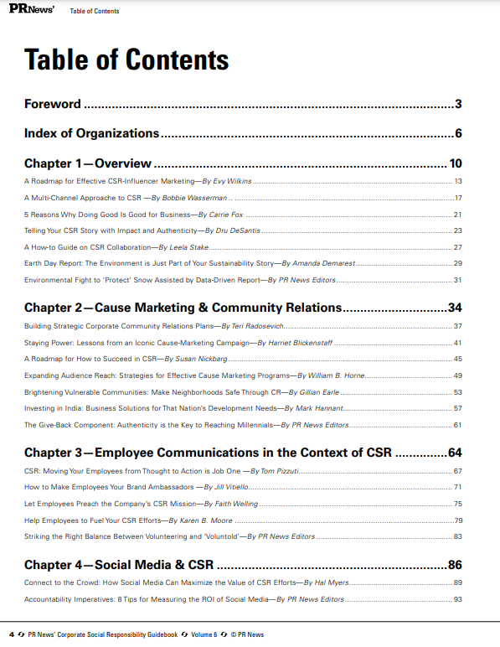
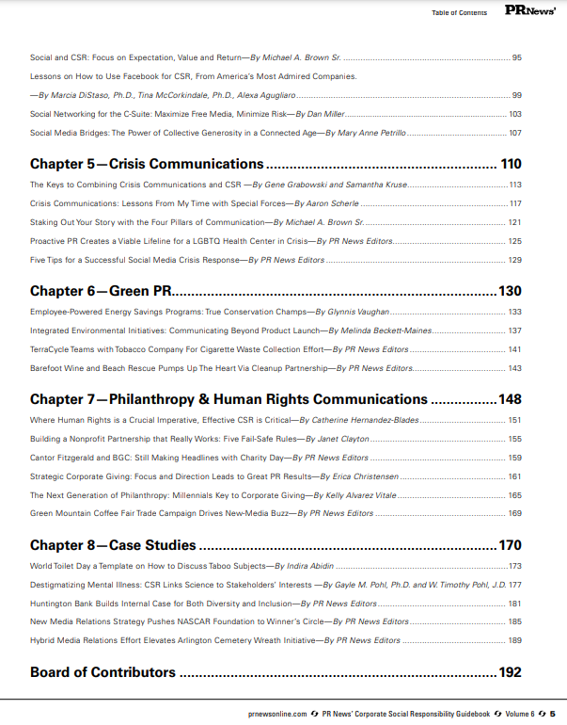
CRISIS COMMUNICATIONS
Take control of your story with 4 pillars of communication
By Michael A. Brown Sr., Ph.D.

For communicators, every crisis response is about the public story being told. In response, companies are concerned about their role in the event, but also must focus on responsibilities to affected communities. Planning tends to be the easy part because companies can do that in advance, and most do. But corporate social responsibility (CSR) objectives can take a beating without good crisis communications that incorporate sound social media practices.
In a 2010 cause marketing study conducted by Cone Communications (http://www.conecomm.com/2010-cone-cause-evolution-study), 85 percent of consumers have a more positive image of a product or company when it supports a cause they care about. The survey results point to the reasons why many major B2B corporations are developing significant and strategic corporate social responsibility initiatives—including employee community service, corporate giving programs or sponsorship of local projects or events. Success in these activities can create a kind of credit during emergencies, when people in communities welcome the comfort of someone they know and have worked with.
I recommend that organizations include social media as a primary tool in their crisis communication toolbox. Further, effective use of the pillars of social media strategy can pay big dividends. Also, creating a social media culture that operates equally well internally and externally may be the most valuable thing organizations can do.
Lon Safko’s Social Media Bible (2009) established 4 pillars of social media that lead to successful participation. These pillars – communication, collaboration, education, and entertainment – can encourage success in crisis communications. Using the pillars, companies can communicate with the media and interested publics, collaborate with involved responders to get the story right early and often, educate the public on what is being done, or ease the state of mind with interesting details concerning activities (entertain).
Everyone has a formula for success in crisis communications. I think many companies also stress the presence of a written plan, tactical preparedness, training in crisis communication activities, maintenance of contact lists, and media monitoring. At Joint Task Force Civil Support, where I’m deputy director of Public Affairs, we have a straightforward approach:
1. Get the story out as soon as possible; no need to wait for the media to break the story first.
2. Craft your messages in advance, make sure your team members know them, and always comment when given the opportunity.
3. Ensure your spokespersons tell the truth.
4. If you can’t answer or you don’t know the answer, say so.
5. Stick to the event and to the facts.
6. Stay in your lane; stick to your role in the event and your expertise.
7. Don’t get emotional when media coverage is off the mark or wrong; correct the record and get back to your primary responsibility – the event response.

Of course, the overlay for this approach is communicate, collaborate, educate and entertain (where appropriate). Success in crisis communication requires developing an understanding of practical applications and partnering with others to build community. The organization should already have a plan that addresses goals, establishes roles, and seeks feedback and verification that the response is working.
In my view, any emergency response requires the use of social media, the fastest communication approach available today. Social media presents a fresh approach of Web-based applications and channels that offer citizens opportunities to share constructive ideas and opinions and to play active roles throughout the private and public sectors. In a crisis, people want answers, and they want to be connected to someone who can help, and organizations would be wise to use social media to collaborate with citizens, announce existing services, and develop new initiatives.
While taking advantage of the four pillars is important in my view, I also know that one can’t do everything. So it may be best to focus on one pillar to streamline the approach. In the table below, I offer the properties of my expectation, value and return on investment (EVR) focus to help organizations make decisions on selecting the best pillar for the current strategy.
EVR is a social media focus that presents planning practices that address goals, establish roles, and seek feedback and verification that the social media approach is working. EVR has several objectives. First, identify and improve social media participation by delivering on expectations of shared value and a worthy return on each company’s, or participant’s, investment of time and attention. Second, develop or improve organizational or personal brand using a two-way communication arrangement where valuable information is exchanged freely, and where giving and getting recognition matters to the participants. Third, develop a social media plan that addresses the goals required by the company or personal brand.
In short, I see communication and collaboration as methods that ensure an open door for continuous interactions whenever and wherever they are available. Education is all about leveraging all of the learning styles and venues available through academic pursuits. Finally, entertainment is a way to use humor, emotion, empathy, sympathy, etc., to deliver a message and facilitate communication.

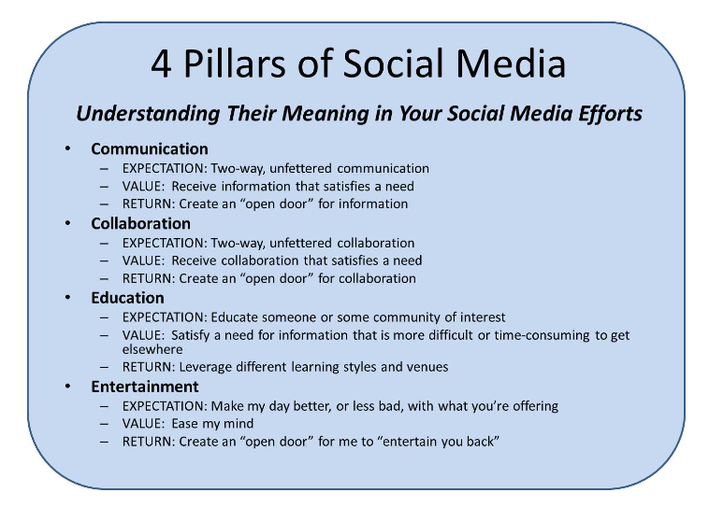

Company strategy based on pillars of social media helps build relational contracts between and among community, stakeholders, employers, employees and coworkers. This is critical in a crisis situation. Employing the pillars of social media is important because CSR comes to the forefront in a crisis. Companies tend to get involved as leaders of the community effort, either because they seek out that role or because there is a void that someone has to fill. I tend to think it’s kind of like governing at that point. And, if you use social media to guide your efforts at that point, the response takes on the traits spelled out in Governing by Network by Goldsmith and Eggers (2004).
A valuable PR approach is creating CSR programs that illustrate responsible leadership and demonstrate community involvement. Goldsmith and Eggers talk about providing greater reliance on networks as a way to deal with making interactions administratively effective and professionally accountable. While the authors are focused on government, I believe the approach has applications far beyond that. Social media allows organizations to rely on a web of partnerships and alliances to meet its goals. That reliance can enhance the capability for leaders to understand whether their investment, in social media for example, will lead to improvements in efficiency or performance. It is also important for leaders to create buy-in for social media efforts before an event requires it.
So how do companies get that buy-in? Right now, today, an effort must be under to discontinue having employees view themselves as doers, locked into simple task completion. For social media to take hold, companies must create a culture where employees view themselves as facilitators, conveners, and brokers of how to engage the community’s talents to accomplish the task at hand. This approach requires less reliance on employees in traditional roles and more on a web of partnerships, contracts, and alliances to do the company’s work. The best way to create that web is through employee engagement during everyday activities.

Goldsmith, S. and W. D. Eggers (2004). Governing by network: the new shape of the public sector. Washington, D.C., Brookings Institution Press.
PaloAltoNetworks (2009). The Application Usage and Risk Report: An Analysis of End User Application Trends in the Enterprise. Sunnyvale, Palo Alto Networks: 1-19.
Putnam, R. D. (1993). Bowling Alone. New York, Simon &amp; Schuster Paperbacks.
Safko, L. and D. K. Brake (2009). The social media bible: tactics, tools, and strategies for business success. Hoboken, N.J., John Wiley &amp; Sons.

Bio

Dr. Brown is deputy director of Public Affairs, Joint Task Force Civil Support (JTFCS), Ft. Eustis, Va. He is also an Air Force retiree.

